**NALAIYA THIRAN PROJECT BASED LEADER**

**ON**

**IOT BASED SAFETY GADGET FOR CHILD SAFETY MONITORING & NOTIFICATION**

**A PROJECT REPORT**

**PUNITHA S 951319106034**

**ABIRAMI S 951319106001**

# REVATHI C 951319106041

**SIVAMALAR T 951319106045**

**BACHELOR OF ENGINEERING**

**IN**

**ELECTRONICS AND COMMUNICATION ENGINEERING**

**JAYARAJ ANNAPACKIAM CSI COLLEGE OF ENGINEERTING**

NAZARETH – 628 617

ANNA UNIVERSITY: CHENNAI 600 025

NOVEMBER 2022

**SI NO**   **TABLE OF CONTENTS** **PAGE NUMBE**

TITLE

# 

# ABSTRACT

1. **INTRODUCTION**

1. **OBJECTIVE**

1. **IDEATION PHASE**

**Literature Survey**

**Empathy Map**

**Ideation**

**Problem Statement**

1. **PROJECT DESIGN PHASE I**

**Proposed Solution**

**Problem Solution Fit**

**Solution Architecture**

1. **PROJECT DESIGN PHASE II**

**Customer Journey Map**

**Solution Requirements**

**Data Flow Diagrams**

1. **PROJECT PLANNING PHASE**

**Prepare Milestone and Activity List**

**Sprint Delivery Plan**

1. **PROJECT DEVELOPMENT PHASE**

**Project Development – Delivery of Sprint – 1**

**Project Development – Delivery of Sprint – 2**

**Project Development – Delivery of Sprint – 3**

**Project Development - Delivery of Sprint - 4**

1. **CONCLUSION**

1. **REFERENCES 36**

**ABSTRACT**

Nowadays, crime rate associated with children keeps increasing due to which draws peoples’ attention regarding child safety. This research is conducted to propose a child security smart band utilizing IoT technology. Online questionnaire and semi-structured interview are methodologies used to collect data. The online questionnaire gains feedbacks by sending questions electronically, where answers need to be submitted online. In the semi structured interview, researcher meets and asks respondents some predetermined questions while other being asked are not planned in advanced. Through information obtained, a smart band have been proposed to monitor the safety of children. By this, parents know what is happening remotely and can take actions if something goes wrong. The future improvements of this device will be adding functions and software to make it works like a phone such as messaging, gallery, Google, YouTube, meanwhile, adding more child security features so that child safety is guaranteed. Keywords: Child security system, Child monitoring system, Internet of Things (IoT), IoT device, Smart band.

**1.INTRODUCTION**

Internet of Things (IoT) is a set of systems and devices interconnected with real-world sensors and actuators to the Internet, according to It is able to make decisions via detecting the surrounding environment without human interaction.In this research, IoT is applied to propose a wearable smart band which helps parents to monitor and get known of their child’s condition at anywhere and anytime even if they are not by their children side. Via the IoT smart band, children safety is guaranteed, and crime rate is reduced as immediate actions can be taken in case the child is in danger. Besides, unlike existing smart band, which is less focusing on child security aspect, the proposed system emphasizes in getting as much data as possible so that actual situation can be identified. The use of IoT in this device is motivated by the need of child security system in Malaysia due to child safety issues resulting from increasing cases on child related crime. In fact, IoT has been applied in domains such as smart home, smart city, smart factory, supply chain, retail, agriculture, lifestyle, transportation, emergency, health care, environment, energy, culture and tourism. However, it is seldom used to monitor child’s safety in Malaysia. Actually, there is a need to use IoT-based child security system since the safety of children has become a major concern . In fact, crimes on children keep increasing despite actions have been taken by the government. Revealed by , the overall percentage of child abasements worldwide is about 80% nowadays, out of which 74% are girls and the remaining are boys. For every 40 seconds, a child is gone missing in the world. Due to that, parents are worried for their children andperhaps, a hard challenge for them to guarantee safety of their children when they are out. To cope with the issue, the system is proposed with these objectives:

Enable tracking of the child’s location and capturing of data remotely such as temperature, pulse, respiratory rate, quality of sleep and many more.

➤ To show the child's actual data with reference values

➤ Sending of notification if the child is out of location or when the device realizes abnormal conditions/situations

➤ To trigger the alarm and enable automatic video recording whenever the emergency button is pressed. Then, emergency notification along with real-time video will be sent to and display in the parents' mobile apps.

1. **OBJECTIVE**

The objective is to monitor the child safety of the system, that consists of Wi-Fi module used to implement IoT and send all the monitored parameters to the cloud for android app monitoring on parental phone. Panic alert system is used during panic situations alerts are sent to the parental phone, seeking for help also the alert parameters are updated tocloud.

1. **IDEATION PHASE**

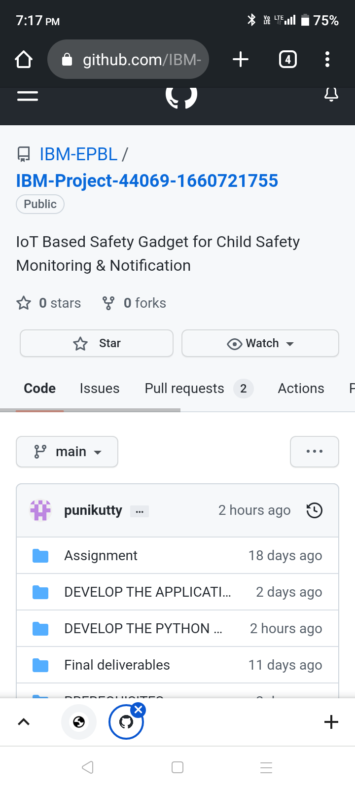

3.1 **Literature Survey**

3.2

. The overall percentage of child abusements filed nowadays in the world is about 80%, out of which 74% are girl children and the rest are boys. For every40 seconds, a child goes missing in this world. Children are the backbone of one's nation, if the future of children was affected, it would impact the entire growth of that nation. Due to the abusements, the emotional and mental stability of the children gets affected which in turn ruins their career and future. These innocent children are not responsible for what happens to them. So, parents are responsible for taking care of their own children. But, due to economic condition and aims to focus on their child's future and career, parents are forced to crave for money.Hence, it becomes difficult to cling on to their children all the time. In our system,we provide an environment where this problem can be resolved in an efficient manner. It makes parents to easily monitor their children in real time just like staying beside them as well as focusing on their own career. With this motivation, a smart IoT device for child safety and tracking is developed to help the parents to locate and monitor their children. The system is developed using LinkIt ONE board programmed in embedded and interfaced with temperature, heartbeat, touch sensors and also GPS, GSM & digital camera modules.

**Empathy Map**

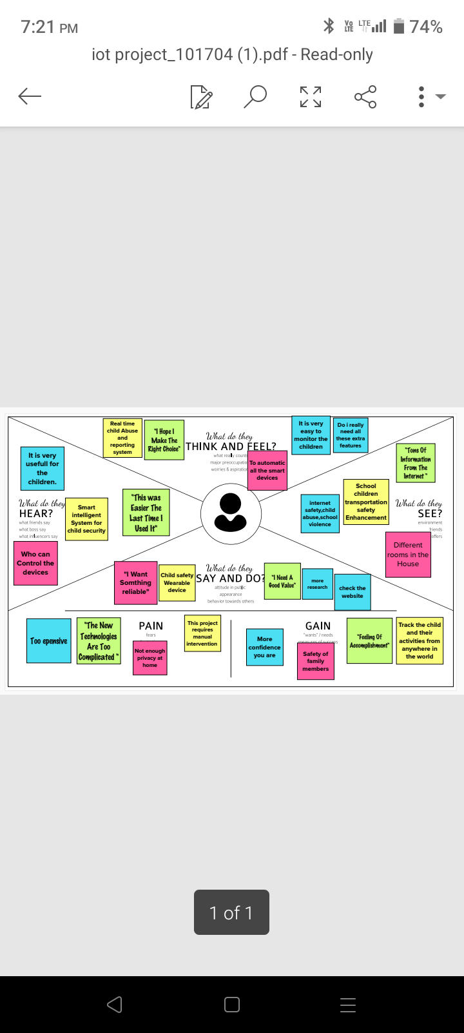

# Figure 1 : Empathy Map

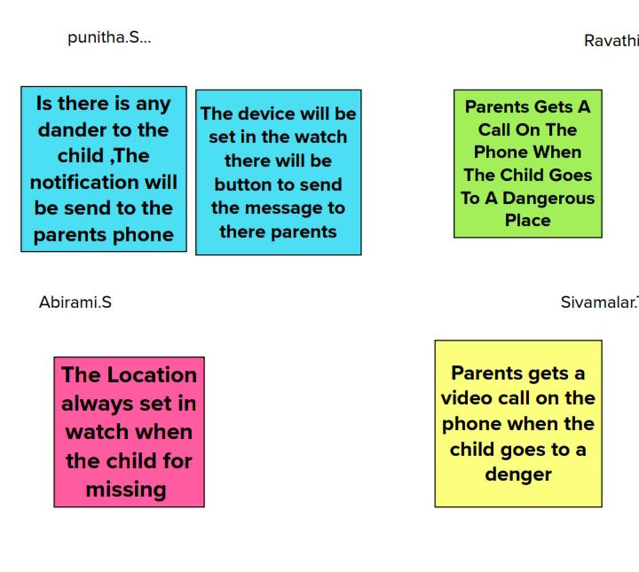

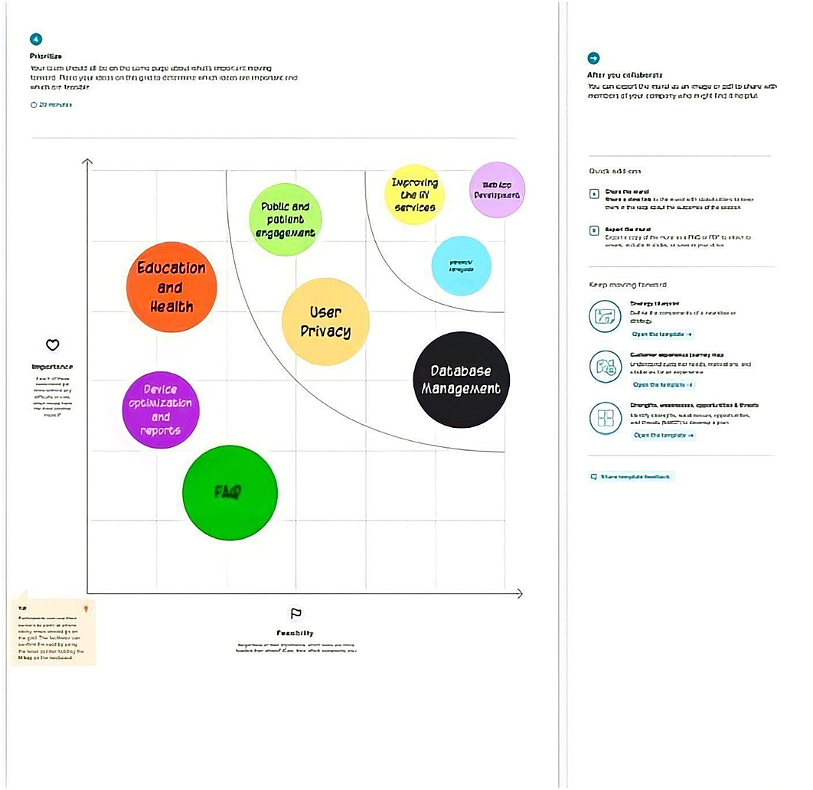

**Table 1: Problem Statement**

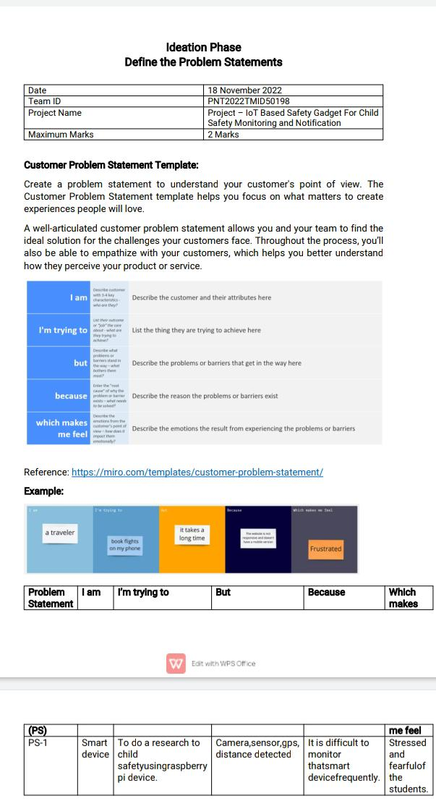

**Figure 5**

|  |  |
| --- | --- |
| **Problem Statement (PS):** | The safety device protects individuals from potential harms and dangers .A research doneby proposed the child safety wearable device using raspberry pi3.The raspberry pi 3 gathersdata from pi camera, pulsesensor and sound sensor. Then, send collected data to parents smart phones by SMS using GSM shield. |
| **I am (USE**  **R)** | Smart device |

|  |  |
| --- | --- |
| **I’m trying to** | To do a research to child safetyusing raspberry pi device. |
| **But** | Need camera, sensor , sound sensorsto do this. |
| **Because** | It is difficult to monitor thatsmart device frequently. |
| **Which makes me feel** | Stressed and fearfulof the students. |

# 4. PROJECT DESIGN PHASE I

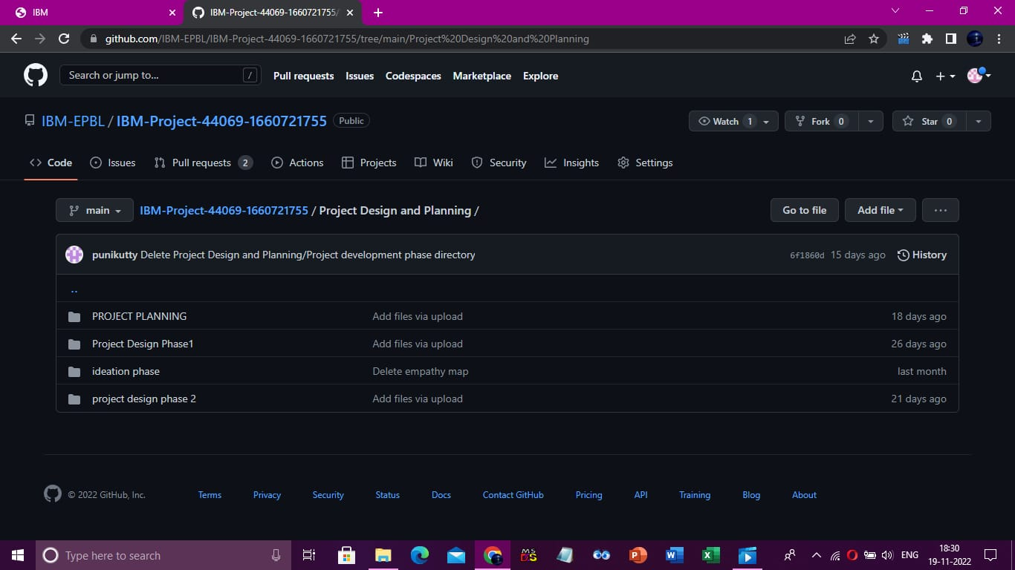

**Proposed Solution**

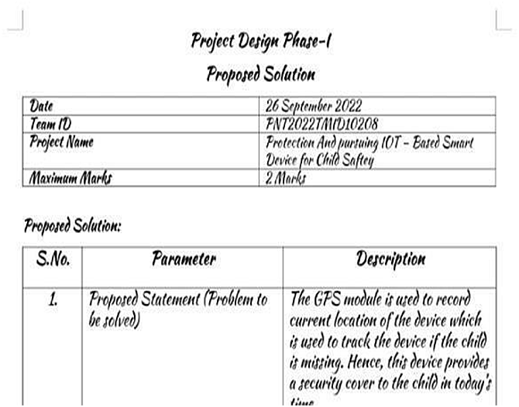

**Table 2: Proposed Solution**

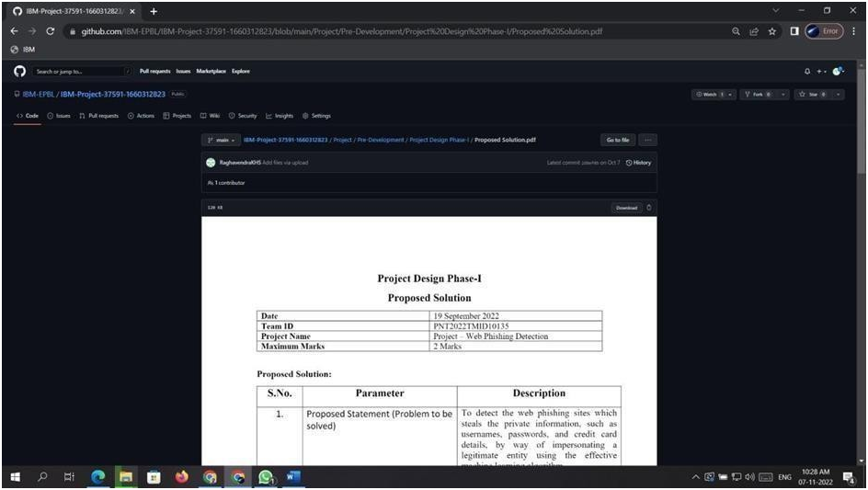

|  |  |  |
| --- | --- | --- |
| **S.N**  **o.** | **Paramet er** | **Descripti on** |
| 1. | Proposed Statement (Problem to be solved) | The GPS module is used to record current location of the which is used to track the device if the child is missing .Hence ,this device provides a security cover to the child in today’s time. |
| 2. | Idea / Solution Description | The child safety wearable device is capable of acting as a smart IOT device.It provides parentswith the real – time location,surrounding temperature, UV radiation index and SOS light along with distress alarmbuzzer of theirchild’s surroundings and the ability to locate their child or alert bystanders in acting to recuse or comfort the child. |

|  |  |  |
| --- | --- | --- |
| 3. | Novelty / Uniqueness | The novel zig bee based temperature and also bloodpressure monitoring systemusing wireless communication technology |
| 4. | Social Impact /  Customer Satisfaction | 1. It will save the users from fraudulent websites and reduced   globaleconomical losses causedby web phishing every  year.   1. It providesthe users a highly safe and secured environment to search through |

|  |  |  |
| --- | --- | --- |
|  |  | internet and make payment and other activities     1. It gives a reliable way to detect web phishing and scamming sites      1. It provides a secured and Confidential environment for e-banking      1. It provides a completely Authenticated sites for userssafe and protected   transitions |
| 5. | Business Model(Revenue Model) | Cyber ThreatIntelligence it is a commercial web phishing protection software or web extension tool that helps and protects the user from web phishing by automatically detecting phishing sites by AI &ML based detection system Bank transactions |
| 6. | Scalability of the solution | It will be usefulfor a wide range of users fromindividual users to corporates, banksand universities. Helps in reducing economical loss caused by these web phishing incidents and also protects from confidential and personal information losses |

**Problem SolutionFit**

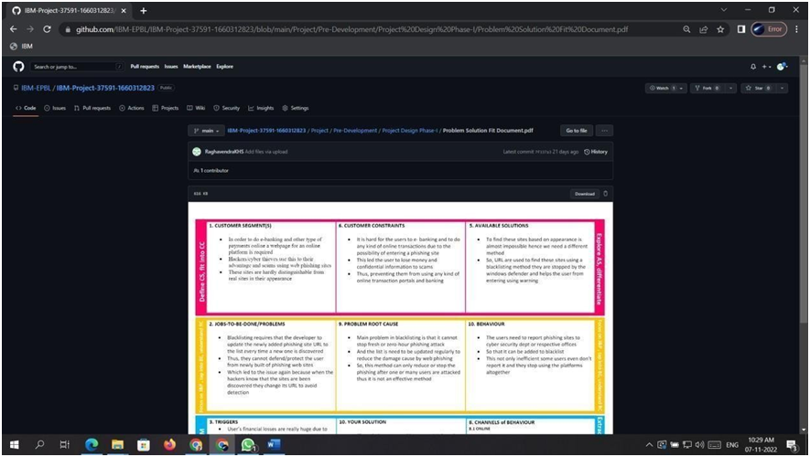

5.PROJECT DESIGN PHASE II



**Customer Journey Map**

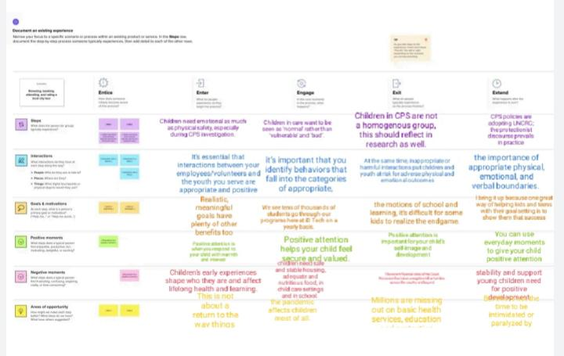

**Figure 8: Customer Journey Map**

**Solution Requirements**

**Table 3: Functional Requirements:**

Following are the functional requirements of the proposed solution.

|  |  |  |
| --- | --- | --- |
| **FR**  **No.** | **Functional**  **Requirement (Epic)** | **Sub Requirement (Story / Sub-Task)** |
| FR-1 | User Input | Camera , heartbeat sensor. |
| FR-2 | Feature extraction | The data from camera is extracted and compared withhelp of IOT.The output of the sensor is extracted to check healthcondition of the child. |
| FR-3 | Prediction | Compare to the datastored in API,theoutput of thegadget can be measured. |
| FR-4 | Classifier | With the help of internet connectivity output from the sensor and camera , are categorized  and classified underthe category basedon the child activity. |
| FR-5 | Announcement | The modeldesigns the outputand visualizes theoutput. Based on the value  , we can  monitor and detect the child is in safe condition on unsafe condition. |
| FR-6 | Accuracy | The outputvalues are obtained for every setof data received. |

**Table 4: Non-functional Requirements:**

Following are the non-functional requirements of the proposed solution.

|  |  |  |
| --- | --- | --- |
| **FR**  **No.** | **Non-**  **Functional**  **Requirement** | **Description** |
| NFR- 1 | **Usability** | Users cangive the inputdirectly in thetext bar provided in the interface. |
| NFR- 2 | **Security** | The application does not store anysensitive and personal data of the user. |
| NFR-  3 | **Reliability** | The predictions are made based of verified AI model which has been tests multiple times. |
| NFR- 4 | **Performance** | The accuracy is high and it can predict accurately than existing any traditional detection method. |
| NFR-  5 | **Availability** | It is available andcompatible on allplatform and devices. |
| NFR- 6 | **Scalability** | The application can be usedamong all people across worldwide and adapt elsewhere. |

**Figure 10: Data Flow Diagram**

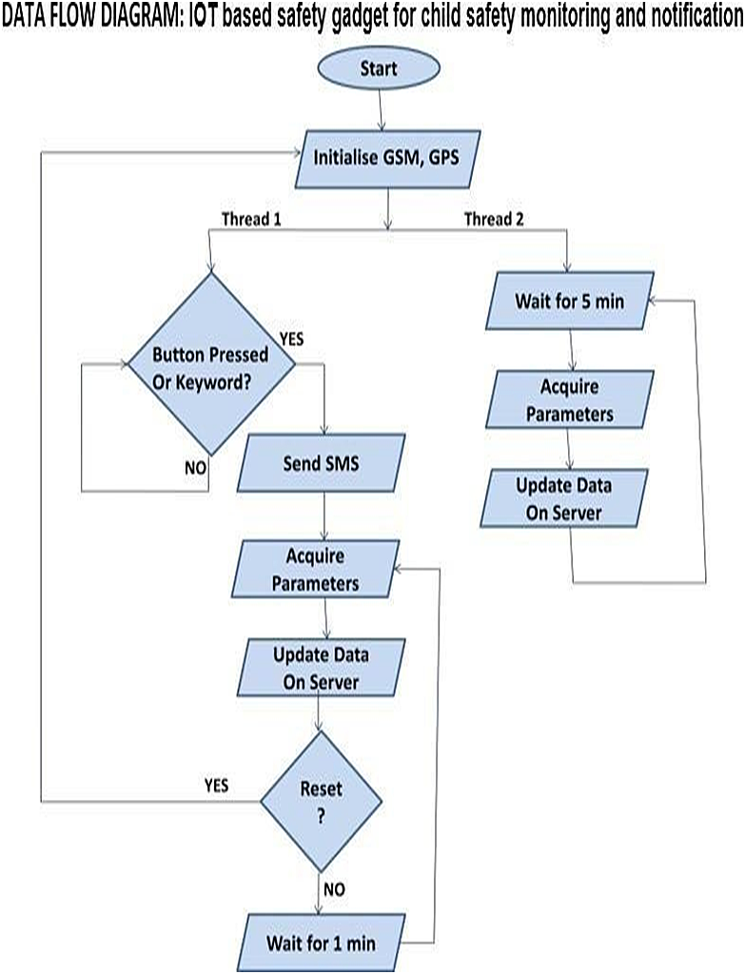

**TechnicalArchitecture:**

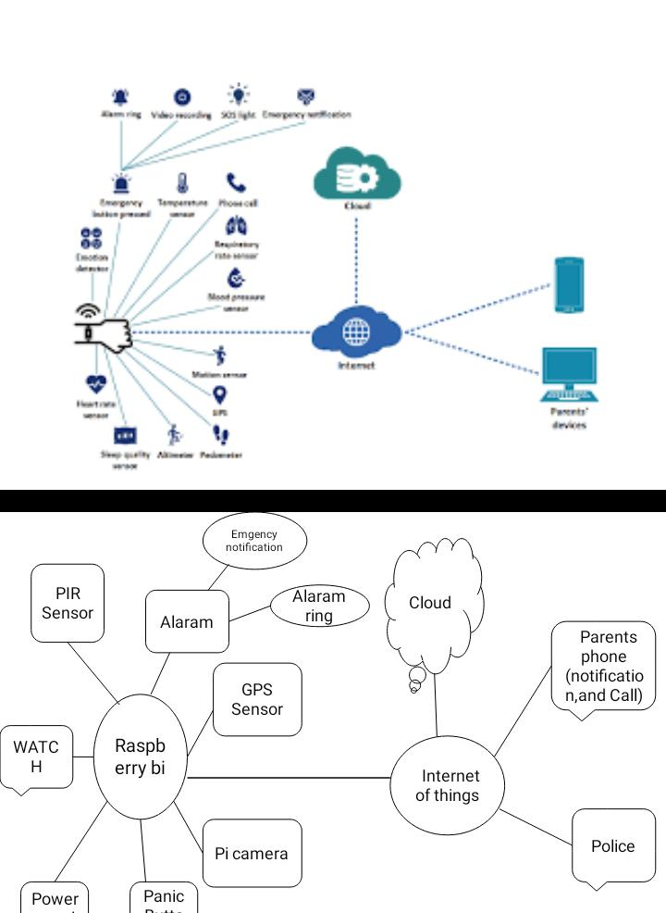

**Figure 11: Technical Architecture**

**Table-5:Components & Technologies:**

|  |  |  |  |
| --- | --- | --- | --- |
| **S.No** | **Component** | **Description** | **Technology** |
| 1. | Gate way | An IOT gateway is a centralized hub that connects IOT devices and sensor to cloud based computing and data processing. | TCP IP protocol |
| 2. | Temperature sensor | The temperature and wetnesssensor detects the temperature and wetness of the baby and if itincreases a particular level, the message will be sent to the parents. | Infrared (IR) sensor |

|  |  |  |  |
| --- | --- | --- | --- |
| 3. | Touch sensor | The NEO 6M GPS is used asthe basis for a complete GPS module. | capactive |
| 4. | Heart sensor | Maxim’s MAX30100  integrated pulse oximetry and a heart rate sensor. | Photo plethysmograph(ppg) |
| 5. | GSM module | The global systemfor mobile communications module is monitoring. | Standard based low power widearea. |

**Table-6: Application Characteristics:**

|  |  |  |  |
| --- | --- | --- | --- |
| **S.No** | **Characteristics** | **Description** | **Technology** |
| 1. | Real time location | IOT enabled child location tracking solutions use GPS and mobile data to allow parentsor guardians to monitor. | Global navigation satellite system (GNSS) network |
| 2. | Gadget plug and unplug monitoring | This featuresis to keep monitoring if the safety gadgetis plugged or not by monitoring. | chrome |
| 3. | Stay connected feature | Stay connected feature is used to triggercall and predefined SMS anytime from gadget . | Technology used |
| 4. | Gate way | GPS location sensor | Same  technology is  used . |

# 6. PROJECT PLANNING PHASE



**6.1 Sprint DeliveryPlan**

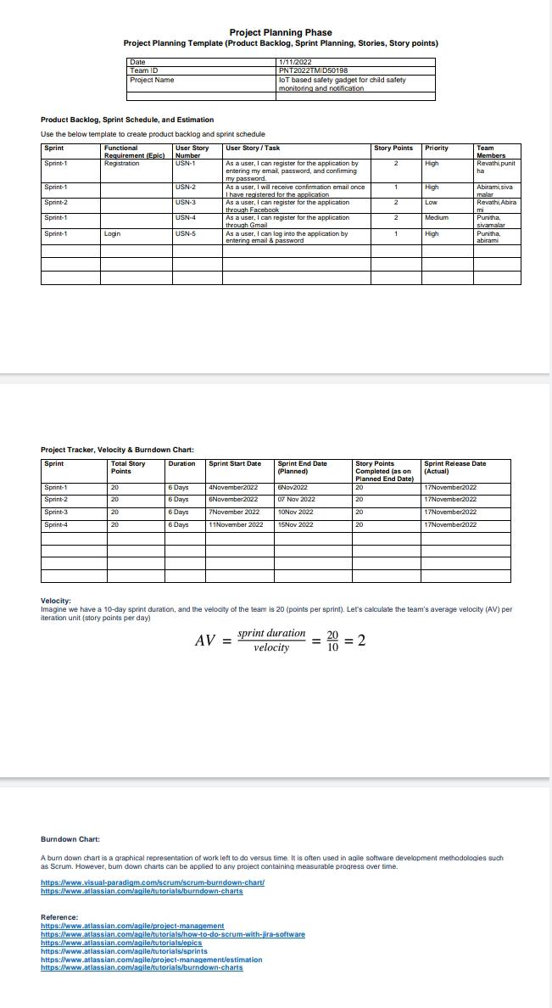

**Table 8: Product Backlog,Sprint Schedule, and Estimation (4 Marks)**

Use the below templateto create productbacklog and sprint schedule

|  |  |  |  |  |  |  |
| --- | --- | --- | --- | --- | --- | --- |
| **Spri nt** | **Functional** **Requireme**  **nt (Epic)** | **User**  **Story**  **Numb**  **er** | **User Story / Task** | **Story Poin**  **ts** | **Priori ty** | **Team**  **Members** |
| Sprin  t-1 | Registration | USN-1 | As a user, I can register for the application by entering my email and password and  confirmi ng my password. | 4 | High | SUDHA |
| Sprin  t-1 | Confirmat ionemail | USN-2 | As a user I will receive a confirmation email onceI have registered for the  application. | 4 | High | SWVAT  HA LAKA |
| Sprin  t-1 | Authentication | USN-3 | As a user I can register forthe application through gmail and mobileapp. | 4 | Medi um | SUSMITHA |
| Sprin  t-1 | Login | USN-4 | As a userI can log into the application byentering email  &password | 4 | High | SUBAA  SRI |
| Sprin  t-1 | Dashboard | USN-5 | As a user I need to be ableto view the functions that I  canperform. | 4 | High | SUDHA,S  WVATHAL  AKA |
| Sprin  t-2 | Notifications | USN-6 | As a user, I should be able to notifymy parent and guardian in emergency  situtations. | 1 | Medi um | SUSMITH  A, SUBAA  SRI |

|  |  |  |  |  |  |  |
| --- | --- | --- | --- | --- | --- | --- |
| Sprint-2 | Store data | USN-1 | As a user I need to continuously store my  location data into the database. | 1 | Low | SWVATH  ALAKA,SU  BAA SRI |
| Sprint-3 | Communication | USN-4 | As a user I should be able  to communicate with my parents. | 1 | Medium | SUDHA,SU  SMITHA |

**Table 9: Project Tracker,Velocity & BurndownChart: (4 Marks)**

|  |  |  |  |  |  |  |
| --- | --- | --- | --- | --- | --- | --- |
| **Spri nt** | **Total**  **Story Poin**  **ts** | **Durati on** | **Sprint**  **StartDa**  **te** | **Sprint End**  **Date(Planne d)** | **Story**  **Points Complet**  **ed (as on**  **Planned**  **End Date)** | **Sprint**  **Release**  **Date**  **(Actua**  **l)** |
| Sprin  t-1 | 20 | 6 Days | 24 Oct  2022 | 29 Oct 2022 | 20 | 29 Oct  2022 |
| Sprin  t-2 | 20 | 6 Days | 31 Oct  2022 | 05 Nov 2022 | 20 | 05 Nov  2022 |
| Sprin  t-3 | 20 | 6 Days | 07 Nov  2022 | 12 Nov 2022 | 20 | 12 Nov  2022 |
| Sprin  t-4 | 20 | 6 Days | 14 Nov  2022 | 19 Nov 2022 | 20 | 19 Nov  2022 |

# 7.PROJECT DEVELOPMENT PHASE

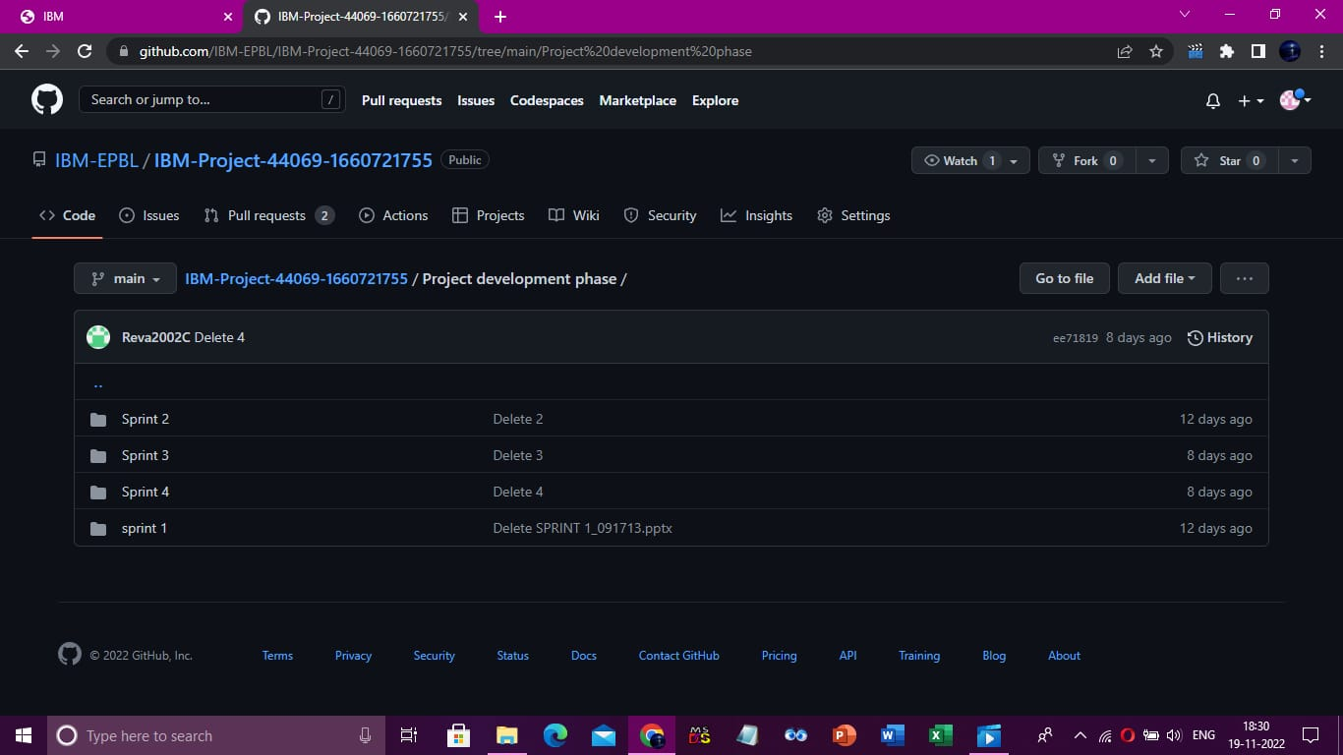

**Project Development – Delivery of Sprint 1**

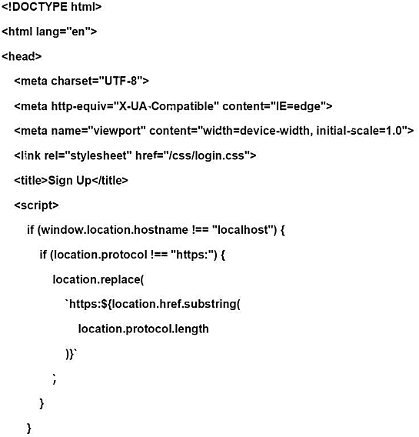

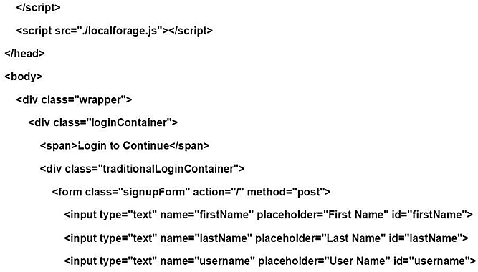

**8.CONCLUSION**

Early childhood development is crucial to how a person develops later on in life. Reasons for a how a person acts, behaves, and thinks can be traced back to their childhood circumstances and environment. Parents also play a very important role in a child's development. Parents not only need to love and understand their child, but also bear the responsibility for 'the upbringing and development of the child' (Article18). The child'smaterial standard of living should be adequate for 'the child's physical, mental, spiritual, moral and social development' (Article 27)  **9.REFERENCES**

1. Anderson, G. R. (1997). Introduction: Achieving permanency for all children in the child welfare system. In G. R. Anderson, A. Ryan, & B. Leashore (Eds.), The challenge of permanency planning in a multicultural society(pp. 1-8). New York: HaworthPress, Inc.
2. Ards, S., Chung, C., & Myers, S. (1999). The effects of sample selection bias on racialdifferences in child abuse reporting. Child Abuse and Neglect, 23 (12), 1211-1215.

1. Beeman, S., & Boisen, L. (1999). Child welfare professionals' attitudes toward kinshipfoster care. Child Welfare, 78 (3), 315- 338.

1. Benedict, M.I., Zuravin,S., & Stallings, R.Y. (1996). Adult functioning of children who lived in kin versus nonrelative family foster homes. Child Welfare, 75 (5), 529-549.

1. Boyd-Franklin, N. (2003). Race, class, and poverty. In F. Walsh (Ed.), Normal family processes: a growing diversity and complexity (pp. 260-279). New York: Guilford Press.

1. Courtney, M.E. (1997).The politics and realities of transracial adoption. Child Welfare, 76 (6), 749-779.

1. Deater-Deckard, K., & Dodge, K. A. (1997). Externalizing behavior problemsand discipline revisited: Nonlinear effects and variation by culture, context, and gender.

Psychological Inquiry, 8, 161-175.

1. Eckenrode, J., Powers, J., Doris, J., Munsch, J., & Bolger, N. (1988). Substantiation of child abuse and neglect reports. Journal of Consulting and Clinical Psychology, 56

(1), 9-16.

1. Garcia Coll, C., & Magnuson,K. (1997). The psychological experience of immigration: A developmental perspective. In A. Booth, A. Crouter & N. Landale (Eds.) Immigration and the family: Research and policy on U.S. immigrants.

Mahwah, NJ: Erlbaum.

10.Hill, R. B. (2001). The role of race in foster care placements. Paper presentedat The Race Matters Forum sponsored by the University of Illinois at Urbana-Champaign, Chevy Chase, MD.

11.Johnson, O., Rawle, M., Roberts, J., Morrill, W., & Ooms, T. (1995). Coordination, collaboration, integration: Strategies for serving familiesmore effectively, Part two: State and local initiatives. Washington, DC: American Association for Marriage and Family Therapy.